Progressive Muscle Relaxation
 | Squeeze both hands like you are squeezing a lemon and getting all of the juice out of them!  1-2-3-4-5
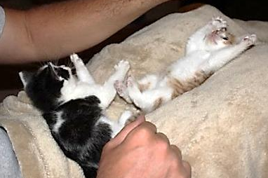 | Stretch forward like a cat; go forward as far as you can!  1-2-3-4-5  Stretch up towards the ceiling like a cat and stretch as tall as you possibly can, taller!  1-2-3-4-5
 | Pretend someone put an ice cube down your back and you are trying to get it out.  1-2-3-4-5
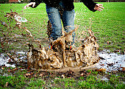 | Pretend you are in a big mud puddle and squish your toes down in it  1-2-3-4-5  Now pull your toes out of the mud puddle and flex them towards your nose  1-2-3-4-5
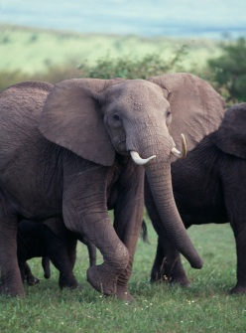 | Tighten your stomach really tight like an elephant is going to step on it  1-2-3-4-5  Uh oh! There is a baby elephant coming, tighten it again! 1-2-3-4-5
Oh no! There is a fly on your nose and you can’t get it off
with your hand, scrunch your nose so it will go away!
1-2-3-4-5

Now it’s on your forehead, tighten your face so it will fly away!
1-2-3-4-5

