When kids have this symptom | It might look like on of these things | You can help them do one of these things
RE-EXPERIENCING | Intrusive recollections/ repetitive play | Thought stopping
 | Bad dreams | Thought replacement
 | Flashbacks | Grounding Nightmare Rehearsal
 | Psychological reactivity | Deep Breathing
 | Physiological reactivity | 4321
 |  | Progressive Muscle Relaxation
AVOIDANCE | Avoiding thoughts/feelings | Grounding
 | Avoiding activities/people | Mindfulness, visualization
 | Forgetting | Roller Coaster/Anxiety Hierarchy
 | Diminished interest | Deep Breathing
 | Detachment or estrangement
 | Restricted affect
 | Foreshortened future
INCREASED AROUSAL | Sleep problems | Deep Breathing
 | Irritability/Anger | Guided Imagery
 | Concentration problems | Progressive Muscle Relaxation
 | Hypervigilance | 4321
 | Exaggerated startle response

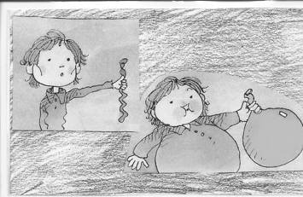 | Pretend your belly is a balloon. Take a deep breath through your nose. Feel your balloon belly fill up with air. Hold it for a few seconds. Breathe out through your mouth, wooosh! Do this at least 5 times!
 | Use a stress ball: SQUEEZE your stress ball as HARD as you can! SQUEEZE for at least 5 seconds. Release, and feel your hand relax. Do this as many times as you need to until you feel CALM
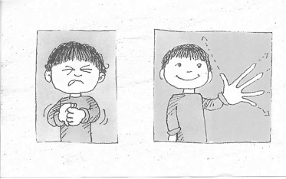 | Squeeze your hands in a fist as hard as you can. Squeeze HARD for 5 seconds! Let go, feel your fingers RELAX. Do this with your other muscles in your body: your arms, stomach, legs, toes…even your nose, eyes, and forehead!
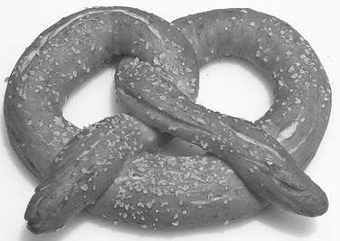 | PRETZEL: Sit in a chair with your legs crossed. Put your arms straight out, with your thumbs pointing down. Cross your arms and hold your hands. Pull your hands up to your chest. Breathe some DEEP breaths…Feel yourself RELAX

