This STOP Plan is for:

__________________________
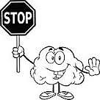
Senses?
Thoughts?
Other helpful thoughts?
Plan and practice!

Senses?  What is going on in my body? What am I feeling?) | Thoughts?  What am I thinking? | Other helpful thoughts?  What is something else  I can think? | Plan and Practice!  What is something calming I can say to myself? What can I do next time?

