Trauma Symptom Activity
USE FOR: Assessment or Psychoeducation Part 1.
This activity could take the place of the symptom rocks.

Age range: ~3- 7 years-old (I did it with a 6 y/o and it worked well).
Materials needed: Book: A Terrible Thing Happened
Two large pieces of paper (butcher paper or large post-it paper)
Crayons/markers
Set of pictures of all trauma symptoms
Tape
1. Introduce the book to the child
2. Have child draw a picture of themselves on one piece of paper (or use gingerbread outline) and of Sherman (character from the book) on the other sheet of paper.
3. As you read through the book, have child tape up all the symptoms that Sherman endorses on his picture.
4. Afterwards, ask child which symptoms they have like Sherman and any other ones that he doesn’t have. Next, have child tape all of their symptoms onto the picture of themselves. Discuss goal to shrink these symptoms and to be able to remove these as they go away.
5. You can keep the drawing of the child with the symptoms and re-assess each week. You can take the symptoms (pictures) down as the child reports not having them any longer (and celebrate this!). When trying to prioritize symptoms, you can have child sort the pictures into different size buckets or bags to show the different intensities. You could also copy the pictures in different sizes to demonstrate their “shrinking”.

This is a good way to normalize symptoms and discuss why we develop trauma symptoms.

Sherman:
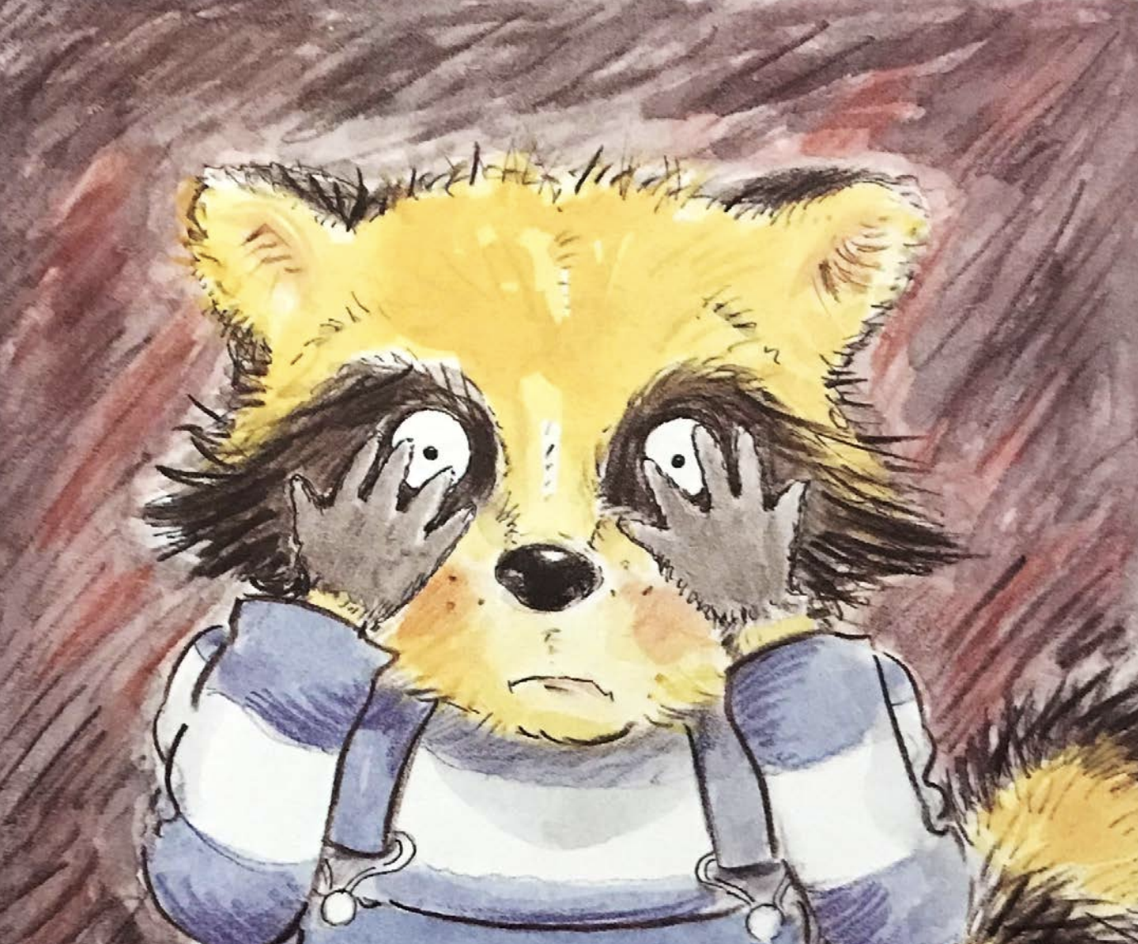

Child:
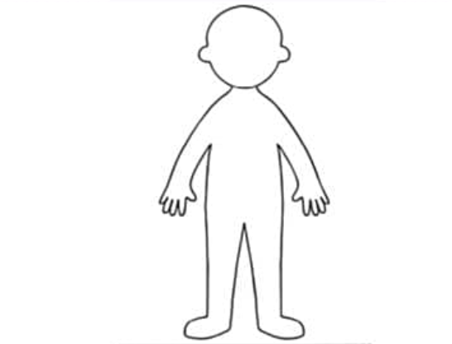
Affect restriction:
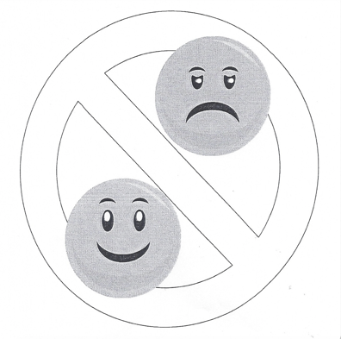

Avoiding activities or people:
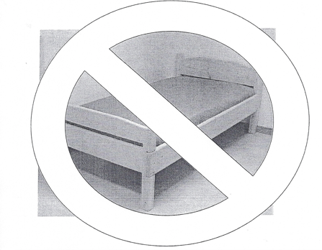

Avoiding thoughts and feelings:
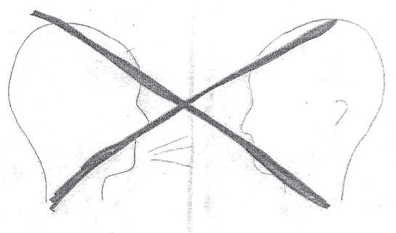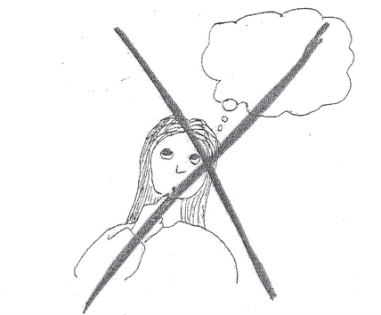

Detachment:

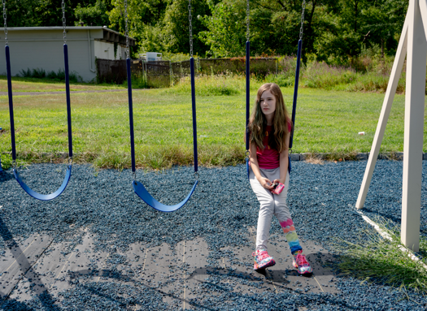

Difficulty concentrating:


Diminished interest:
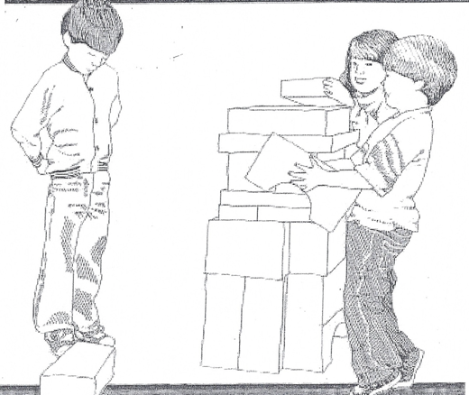

Flashbacks:

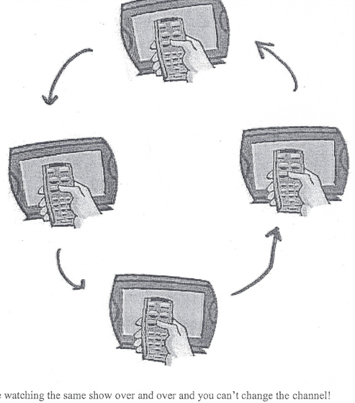

Foreshortened future:
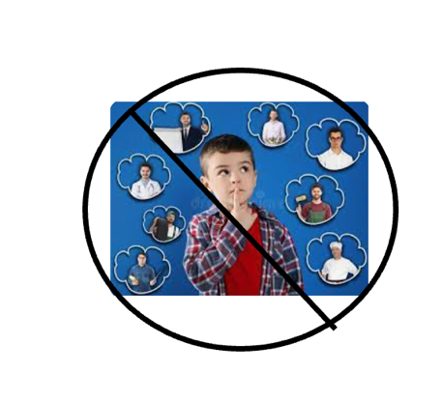
Forgetting:


Hypervigilance:


Intrusive recollections:


Irritability/Anger:
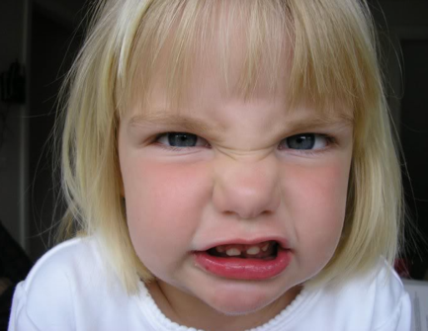

Physiological reactivity:


Bad dreams:



Trouble sleeping:



