By: Meredith Roode
Teaching DV Safety
- Draw (or have them draw) a floor plan of their home, community, school. Talk about how you learn safety in school- ex. Fire drills or tornado warnings.

Example:
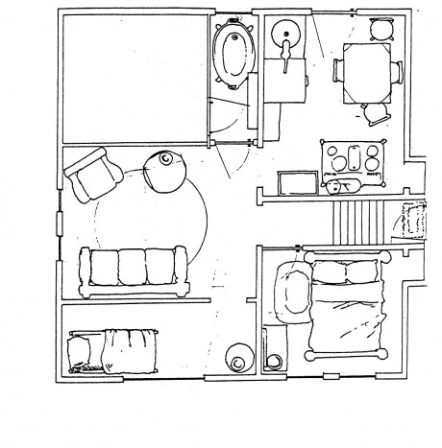
- Focus on safety in their own home- discuss safe/unsafe rooms using the home drawing- the biggest tips I give are not to be in the room where fighting is, not to be in the kitchen (knives, stove, etc), and not to be in the bathroom (usually this is the smallest room in the house and it is very easy to get trapped in)

- Know your ways to get help- can they get out the front door to go to a neighbor, do they have access to a house/cell phone to call 911 or a family member for help, do they live in a one story house if they need to crawl out a window? Use your imagination and try to think of anyway a child could ask for help.

- With little ones I also let them practice calling 911 with this awesome role play app called DialSafe Pro. It helps them know common questions 911 operators ask.


- I also cover emotional safety- because some kids know they are just stuck in the home so how can they not listen to the fight? Go to a safe place and then listen to music or play the tv really loud.


- If mom and kid are the ones engaged in TF-CBT I also cover a possible safe word they can use. I explain that this word is only used when, no question asked, they feel unsafe and need to leave ASAP.

- Just a side note- if it’s a teen the most common thing I hear is that they want to break up the fight. I help them understand this is not safe by explaining their mom’s state of mind. I explain that in a DV fight she needs to be totally focused on keeping herself safe. If a kid gets involved moms usually worry about the child’s safety instead of their own. This is what can lead to both of them being hurt because neither one is focusing on their own safety.
- Also- if mom is really engaged I try to talk to them about making sure their child has a plan. For instance, some kids I work with already have a family plan that if a fight happens the kids know to go to their rooms, lock the door, and not come out. This can get a little sticky if it is a SERIOUS DV family where the kids are truly worried that their mom will be killed by the perpetrator when a fight breaks out. But even if the fight is that bad, a kid still should not be the one to intervene. It would be more important for them to have access to a phone. My agency can give out free 911 phones- the phones are not on a bill but they can still call 911 for families like this.

